Analysis On Overall Sustainability On No Poverty

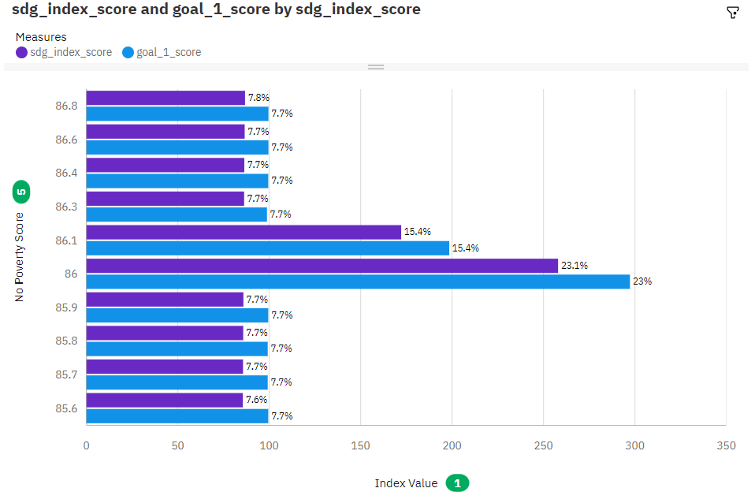

Analysis Overall Sustainability On Quality Education

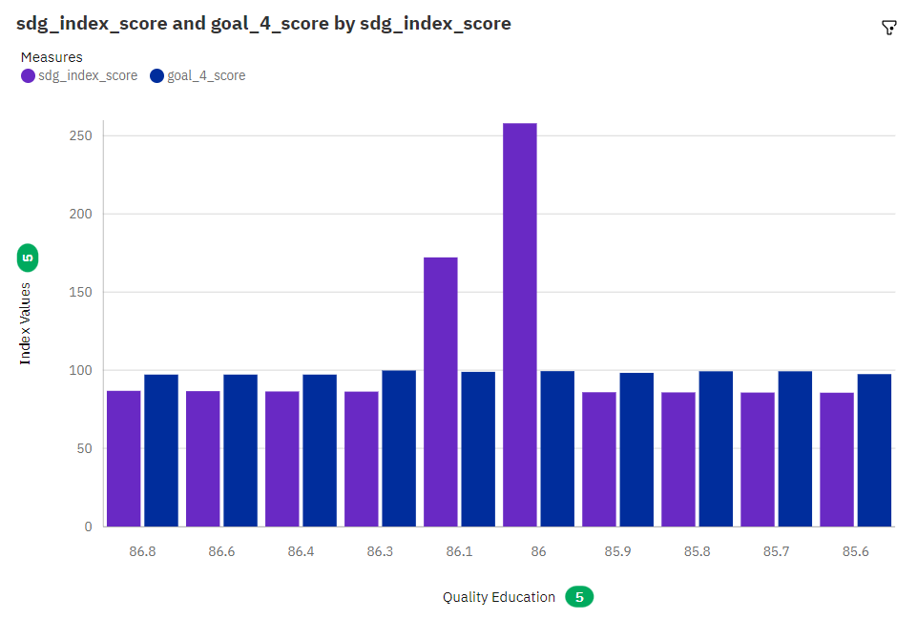

Analysis On Overall Sustainability Life Below Water

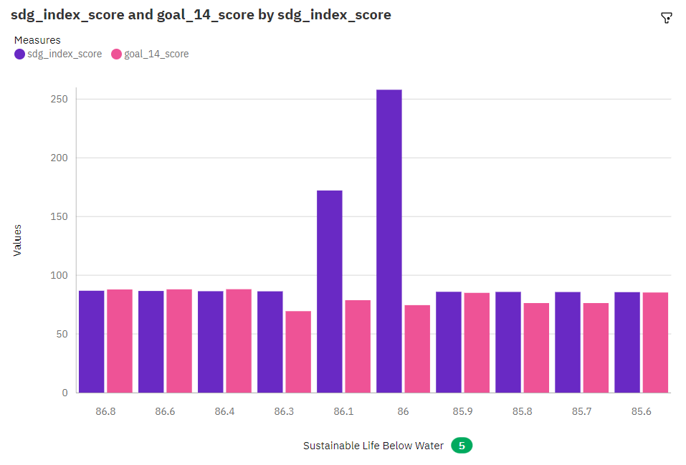

Analysis On Overall Sustainability Partnerships For The Goals

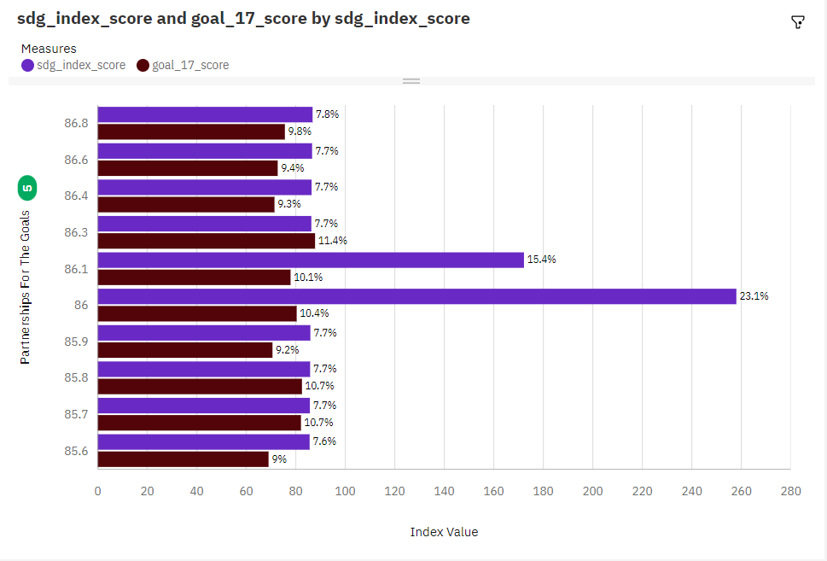

Analysis On Overall Sustainability Reduced Inequalities

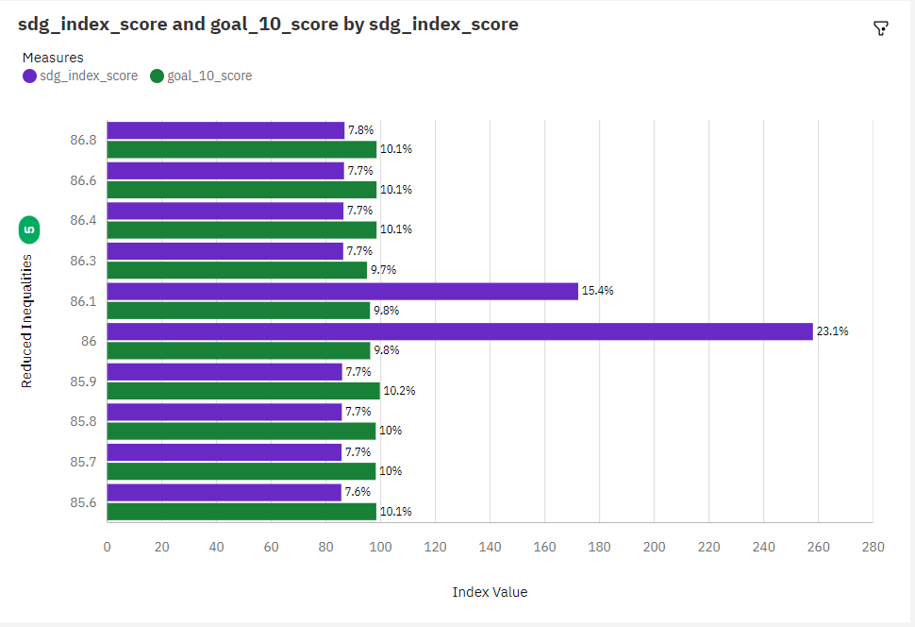

Analysis On Overall Sustainability Industry, Innovation And Infrastructure

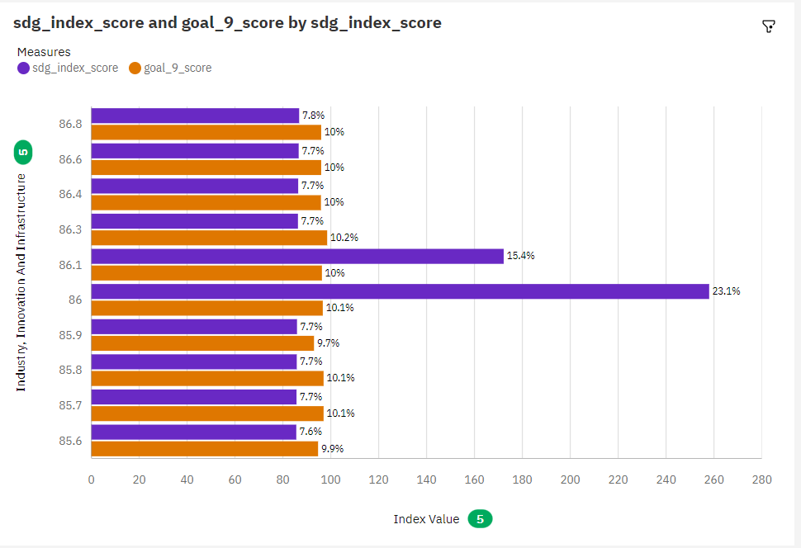

Analysis On Overall Sustainability Life On Land

